Student Name : _______________________________________

**Part One – Resource Free**

Part One contains 6 questions worth 29 marks

Time Allowed : 30 minutes

INSTRUCTIONS TO STUDENTS:

You are required to attempt ALL questions,

Write answers in the spaces provided beneath each question.

Marks are shown with the questions.

Show all working clearly, in sufficient detail to allow your answers to be checked readily and for marks to be answered for reasoning. Incorrect answers given without supporting reasoning cannot be allocated any marks. For any question or part question worth more than two marks, valid working or justification is required to receive full marks.

**Question 1 6 marks**

Let A, B and C be 2x2 arbitrary matrices, and 

Write T (True) and F (FALSE) for each of the following equations:

a)  b) 

False True

c)  d) 

False True

e)  f) 

False True

**Question 2 1, 1, 1, 3 – 6 marks**

Given  find

a)  b) |A| c) A-1

  

d) Matrix C such that A x C = B



**Question 3 6 marks**

a) Given  ,

which two matrices would multiply to give a matrix with order 1 x 2?



b) Given the matrices ,  
which of the following products is not valid?

i)  ii)  iii)  iv) 



c) The translation  is applied to a point  followed by .

Find the combined transformation.



d) What transformation is represented by ?

Rotation AC about the origin of 210°

* ✓ ✓

**Question 4 1, 1, 2 - 4 marks**

Factorise if possible

a)  b)  c) 

 Not possible 

**Question 5 2 marks**

Show that matrices of the form when squared are a multiple of the identity matrix.



**Question 6 5 marks**

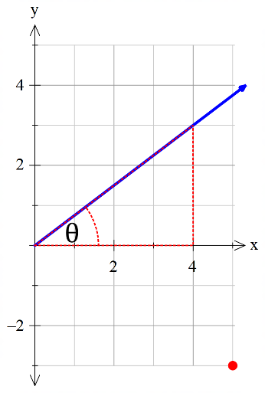

Write the matrix for reflecting the point (5,-3) in the line .

Reflection matrices are of the form



Student Name : _______________________________________

**Part Two – Resource Allowed**

Part Two contains 4 questions worth 31 marks

Time Allowed : 30 minutes

**TO BE PROVIDED BY THE STUDENT**

A maximum of one A4 page of notes, one sided.

Standard Items : Pens, pencils, eraser, sharpener, correction tape/fluid, highlighters, ruler.

Special Items: Drawing instruments, templates.  
A maximum of three CAS calculators satisfying the conditions set by the SCSA.

**INSTRUCTIONS TO STUDENTS:**

You are required to attempt ALL questions,

Write answers in the spaces provided beneath each question.

Marks are shown with the questions.

**Show all working** clearly, in sufficient detail to allow your answers to be checked readily and for marks to be answered for reasoning. Incorrect answers given without supporting reasoning cannot be allocated any marks. For any question or part question worth more than two marks, valid working or justification is required to receive full marks.

**Question 1 3, 4 - 7 marks**

a) Find the greatest value of λ that makes the matrix  singular.



b) Use a matrix method to determine the intersection of the two linear functions 



**Question 2 4, 3, 2, 2, 2, 1 - 14 marks**



a) Determine:

(i) A2, and describe it as a transformation.

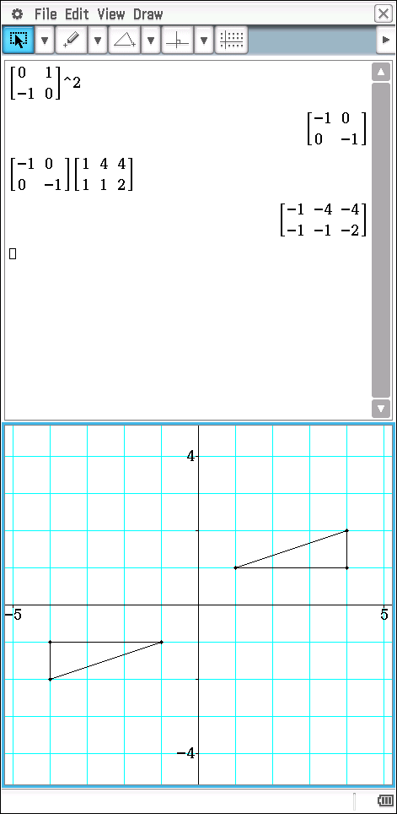



(ii) A3, and describe it as a transformation.

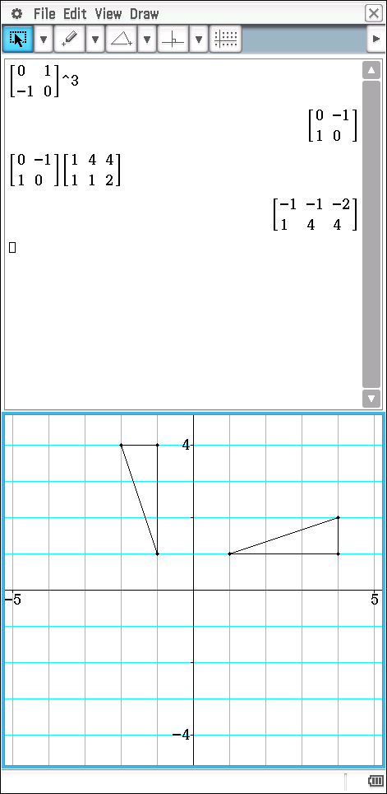



b) If PB = 6[B − 2A], determine P.



c) Find the image of the point P (2, 3) under the transformation that is equivalent to A followed by B.



d) Find the matrix required to transform P’ back to P.



e) If B was applied to a square of side length 5 units, what would be the area of

the resultant figure?



f) If a singular matrix was applied to the square in (d), what would be the shape of

the resultant figure and why?

A singular matrix has a determinant of zero therefore the area of new shape is zero.

Square becomes a line.

**Question 3 3, 3, 1 - 7 marks**

Top Flight Airlines have three types of aircraft available for lights, each with seating for three classes of passengers. The table below summarises the various seating capacities:

|  |  |  |  |
| --- | --- | --- | --- |
| Passenger | Aircraft | | |
| T1 | T2 | T3 |
| Business Class | 80 | 30 | 60 |
| First class | 40 | 60 | 50 |
| Economy class | 40 | 90 | 40 |

This may be represented by the matrix 

a) On a particular day, there are three fully laden flights of type T1, four of type T2 and two of type T3.

i) Represent this data as matrix B.



ii) Calculate AB and indicate what this represents.



b) Each business class ticket sold gives a profit of $120, each first class ticket sold gives a profit of $100 and each economy class ticket sold gives a profit $80.

i) Represent this data by matrix C.



ii) Calculate the total profit for this day using matrix methods.



c) Without necessarily performing matrix multiplication, state what matrix CA represents.

Profit per plane type

**Question 4 3 marks**

Determine the equation of the image line formed when all the points on the line  are transformed by the matrix 

